An integrated method of copy-move and splicing for image forgery detection
Abstract Splicing and copy-move are two well recognized methods of passive image forgery. In this paper, splicing and copy-move forgery detection are performed simultaneously on the same database CASIA v1. 0 and CASIA v2.0. Initially, a suspicious image is occupied and features are extracted through BDCT and enhanced threshold method. The proposed tech- nique decides whether the given image is manipulated or not. If it is manipulated to then support vector machine (SVM) classify that the rendered image is gone through splicing forgery or copy-move forgery. For copy-move detection, ZM-polar (Zernike Moment) is applied to place the duplicated regions in the image. Experimental results depict the public presentation of the proposed method.

Keywords Image forensics · Copy-move forgery · Duplicate region detection ·
Image splicing · BDCT · Zernike moment

Introduction

Image manipulation includes transforming or modifying an image using several methods and image editing tools to reach a desired effect. There are many sophisticated tools/softwares available to alter an image without leaving any traceable proof. Most of the time it is difficult to pick out the forgery thorough naked eyes. At the present time, an image is a viable source of information and it plays a critical part in the courtroom witnesses, insurance claims, scientific scams, medical field, etc. Hence, to ensure its authenticity, researchers have developed sev- oral methods to authenticate digital images. There are two methods to authenticate an image:

Intrusive (active) and Non-intrusive (passive) methods. In intrusive method, prior informa- tion is embedded into the image, like watermarking or digital signature. At authentication stage, it is being tested to assure the legitimacy of the picture. If there is any tampering is made in the image, the extracted watermark or digital signature is not same. By this method, the legitimacy of an icon can be ensured. Only in non-intrusive method, there is no such kind of information is embedded into the image, we have to rely on the intrinsic attributes of the picture. It is also stated as a blind technique to find the image forgery. According to Christlein et al. [12], non-intrusive methods are of two kinds: Copy-move forgery and splic- ing detection. In copy-move forgery, one part is copied and pasted over other region in the same image to conceal some important info. But in image splicing, one area is cut and pasted over other region in different image to produce a raw icon. Grounded along the above classification, the basic principal of forgery detection is to detect the region, which has similar features in copy-move or completely different region in spliced image. All the forgery detection techniques follow the same pipeline i.e. feature extraction, matching and post-processing. For the last decades, image feature detectors are the popular tools in com- puter vision field and been implemented in diverse applications like image representation [56], object identification and matching [3, 13], image classification and retrieval [34, 44], 3Dtion and retrieval [34, 44], 3D
scene construction [37], activity recognition [33, 35, 57–59], text classification [29], robot localisation [9] and biometric systems [25]. All these applications depend on the presence of stable and representative features in the picture. After finding the suitable features, the best couple of each pixel is figured out for the localization of forged parts. To cut the false alarm rate, post-processing is performed.

Motivation and scope

In this report, the proposed method is applied to detect either splicing forgery or copy-move forgery in one case. The principal motivations of our work are:
- The singularity of the advised method is that, hither we are dealing the splicing and copy-move forgery simultaneously. Previously, many methods have been suggested to distribute with the splicing and copy-move forgery, only those methods are used on an individual basis for the sensing of the counterfeit. Consequently, they have utilized the database which is grounded on either splicing or copy-move. In this report we have suggested a method which detects the splicing as well as copy-move forgery on the same database CASIA v1.0.
- To discover the forgery (splicing or copy-move), color space properties of the pictures are
Studied and used Markov feature to press out the features from different color space using the enhanced threshold method. Here, chrominance part of the color image is con- sidered as the chroma channel preserves most of the splicing artifacts. The advantage derived by using chroma channels is given in detail in Section 3.1.
- An enhanced threshold method (Discussed in Section 3.1.3) is inserted to reduce the
feature vector dimension as coMpared to the existing state-of-arts as demonstrated in Table 4.
- For copy-move detection, PatchMatch algorithm is used for matching the features. It is precise for nearest-neighbor to search in an image and processing time is reduced efficiently and also furnish a regular and accurate offset field. The computational complexity analysis is presented in detail in Section 4.3.
The rest of the paper is organized as follows. In Section 2, we discuss the recent state-of-arts related to splicing and copy-move techniques. In Section 3, proposed method is discussed in detail followed by the detailed experimentation in Section 4. The effectiveness of proposed method is concluded in Section 5.

Related works

In this segment, we have talked about some recent techniques developed for image forgery detection. In copy-move forgery the main objective is to obtain the similar regions present in the input picture, while in splicing detection, the seeking of the inconsistencies of features is considered as the solution for this kind of forgery. In malice of the fact that, several related works are available but most of them solve only one problem, either copy-move forgery or splicing in a rendered picture. Yet, very few methods which work out both the forgeries are described in the literature. Thusly, in image forensics, it is even a challenge to produce an algorithm which is not merely limited to copy-move or splicing forgery detection.

Splicing forgery detection

Splicing is a tougher task to perform than copy-move forgery detection. Manipulating an image through splicing is as hard as the detection of splicing forgery. The fundamen- tale concept of various splicing detection technique is to detect the region of inconsistencies with image features. During splicing, the area is usually re-sampled, double compressed and blurred for creating a molded image. This inspires the researchers to develop the differ- ent techniques to find the image splicing. Some of the recently developed techniques are discussed below.
Pun et al. [42] offered a method which is based on noise discrepancies between the original image and spliced image. Initially, the noise level function is calculated and ana- lyzed at pixel level on various scales. The neighborhood which is not under the noise level, termed as suspicious area and inconsistent level of noise indicates the presence of tampering in spliced segments. This technique performs better for multiple spliced object detection. F. Hakim [20] proposed a method based on improved local binary pattern (LBP) and discrete cosine transform (DCT). The chrominance component of the image is divided into non- overlapping blocks. Then improved LBP is calculated for all blocks and using 2D-DCT, it is transformed into frequency domain. Further the frequency coefficients are measured to determine the standard deviation for all blocks which are used as features for classification using k-nearest neighbor.
Shi et al. [47] suggested a natural image model, which educe statistical moments of characteristic function by treating the neighboring differences of BDCT of an image as 1-D signal and the dependencies between neighboring nodes on certain directions have sculpted as Markov model. SVM classifier considered thesE features as discriminating features for categorization. Wang et al. [52] proposed a method in which gray level co- occurrence matrix (GLCM) is considered along certain directions (horizontal, vertical, main and minor stroke) to extract edge images and educed edge images serve as discriminative features for categorization. Xuefang Li et al. [31] proposed a method in which Hilbert-Huang transform and moment of characteristic function of wavelet transform are used for forgery detection. SVM is used as a classifier for spliced image classification in their method and attained an accuracy of 85.86%.
Zho et al. [62] proposed a method in which chroma channel and gray level range-distance features are applied. To extract the features, gray Layer run-length is used along four different directions from de-correlated chroma channel. Then SVM is used for classification based on the extracted features. Wu and Fang [54] suggested a method to detect image splicing using illuminated color inconsistency. Initially, image is divided inTwo overlapping blocks and then applying the classifier, estimated illuminant is selected for further operation. Farther, the difference

Between estimated and reference illuminant color is computed. If the remainder value is more capital than a defined threshold, then the blockage is considered as spliced block.
He et al. [21] proposed a method in which Markov model is introduced in DCT as well as in DWT domain. The difference co-efficient array and transition probability matrix are modeled as feature vector and cross domain Markov feature are considered as discriminative feature for SVM classifier. Nevertheless, the scheme required up to 7290 features. B. Su et al.
[7] proposed a method in which an enhanced Markov state selection method is used. In this method author has considered some already proposed function model and map the large number of coefficients extracted from transforming domain to specific countries. This method gives the detection performance when the number of features is reduced.
Sutthiwan et al. [49, 50] and Wang et al. [53] used the casual Markov model in multi block discrete cosine transform domain (MBDCT) domain and spatial domain respectively to detect image manipulation in chroma channel. Wang et al. [20] applied stationary dis- tribution of Markov chain as a discriminative feature for sorting. Their method shows 99% detection rate on CASIA data set. Later on, Patchara et al. [51] determined that the detection rate achieved by [49, 50, 53] may be due to the artifacts created by post process- ing in CASIA data set. Patchara et al. [51] shown that detection rate of Markov model based feature reduced to 78% for revised CASIA data set. El-Alfy et al. [15] proposed a method in which Markov features are used in both discrete and spatial domain. To pick out the most relevant features, they have used principal component analysis (PCA). Their method suc- cessfully detect the forgery with an accuracy rate of 98.82% using tenfold cross validation technique. X-Zhao et al. [63] proposed a method based on 2-D non casual Markov model for splicing detection. Initially, the input image is molded as a 2-D non casual signal and captures the dependencies between the current node and its neighbors. At once to obtain the discrimi- native features for classification, this model is applied on BDCT and DMWT to extract the characteristics. This method establishes a better detection rate, but at the price of higher proportions of characteristics.
As per the above discussion, it can be reasoned that the Markov model-based approach suffer from information loss and higher feature dimensions which is directly relative to the threshold selection. If the threshold value is larger than the information loss can be reduced, but the feature dimension will be increased which cause over-fitting problem which also involves the detection capability. Hence, selection of threshold becomes a tradeoff between the detection rate and computational cost. In the proposed method, an enhanced threshold method is introduced for image splicing detection, which uses a large threshold value without increasing the features dimension. For color images, it is found that the chrominance portion of an image conserves more hidden splicing artifacts than RGB. Hence, enhanced model is enforced to the YCbCr color space of an image.

Copy-move forgery detection

In general copy-move forgery detection method can be categorized in two groups: Block based methods and Keypoint based methods. The block based methods use blind searching for the image, whereas in key point based methods, the interest stops and key points are detected for matching in an icon. Aside from all these methods every detection algorithm uses a trivial channel [12] which is grounded on these three major steps:

- Feature Extraction: This the The basic tone of any detection algorithm where a relevant feature is captured for each pixel of interest which represents the image nature in its neighbor pixel.

- Matching: After finding the suitable features, the best couple of each pixel is figured out for the detection of forged parts.
- Mail service-processing: To keep apart the best match among the all detected matched pair and to
Reduce the false alarm rate, post-processing is performed.
The above mentioned operations can be applied to each pixel or for any chosen key- points which are not scattered to get a dense offset field. Keypoint based methods are considered faster than those methods which are based on dense matching, because it operates on a relatively modest set of pixel (selected interest points). Pan & Lyu [40] proposed the first algorithm based on key point using SIFT features which deals the different kinds of distor- tions robustly. They have particularly considered the geometrical distortions by RANSAC algorithm [16]. Amerini et al. [1, 2] proposed an alternative of this method in which multiple duplicated regions are taken care of by J-linkage or hierarchical agglomerative clustering algorithm. Similarly, many researchers have developed detection algorithm by characters- in the key points using well-acclaimed local descriptors, like LBP [61], SURF [48], DAISY
[19] and other local features [11, 26].
Despite of the fact that key point based method are faster than dense field, but at the same time it lacks accuracy. The dense field, especially perform well when copy-move associate with only smooth regions, as it is hard to discern the forgery in smooth regions. The per- formance gap illustrated by Christlein et al. [12] motivate us to concentrate on dense field methods.
The problem with the dense field method is complexity. As all the pixel undergoes the com- Mon three phase process for all methods: Feature extraction, matching and post-processing. Hence, it is the prime goal to extract the features as short as possible and simple to increase the speed of the matching process. To solve this problem many researchers have developed an algorithm to reduce the feature length. DCT [10, 17, 23] is used to extract the features and shorten the feature length. Muhammada et al. [38] used DWT for extraction of features and their method shows satisfactory results, but lacks in the case of recycling and rotation. Sim- ilarly, Mahadian &Saic [36] used PCA and Zhao & Guo [61] used SVD for reducing the features length and got satisfactory results, but again the performance reduced when rotation and scaling operation is applied on the image.
To overcome these problems, a significant effort has been made with features which deals with rotation and scaling efficiently. Circular harmonic transform (CHT) provide well- suited features which are rotation invariance. Ryu et al. [46] used Zernike moment, which belongs to the CHT family to extract the features. Y. Li [30] and Li et al. [32] used polar sine and cosine transforms to extract the features for forgery detection.
Apart from the feature selection techniques, matching phase is also considered in recent times. Generally, exhaustive search for the best matching feature is not considered these days due to its high complexity. Hence, faster techniques should be proposed to find the offset field in feasible time. By adopting the approximate nearest-neighbor search strategy, come- plexity problem can be solved, but in this case accuracy becomes a further aspect of interest. These kind of techniques can get the robustness issue against noise and other impairment [5, 8]. To improve the robustness, more practical, fast search techniques like locality hashing
[18] and kd-tree [39] can be used. Langille and Gong [28] and Christlein et al. [12] used kd-tree for matching phase, which is robust against the noise and other post-processing Oper- ations. Ryu et al [46] and Y. Li [30] used locality sensitive hashing in their work for forgery detection.
The above state-of-the-art matching techniques motivate us and we have proposed a tech- unique which is efficient and accurate for detection of copy-move forgery and locate the

Forged region successfully with a number of geometrical transformations. The general work- flow discussed in [12] is considered here, but propose innovative and efficient solutions for most of the key steps of the workflow. For matching of dense features, PatchMatch algo- rithm [4] is used which is precise for nearest-neighbor to search in an image, which also provide a regular and accurate offset field.
Images are a reliable source of information on modern life as it is presented as evidence in courtroom witness, used for insurance claims, medical records and financial documents. Hence, its authenticity is utmost important. To ensure the authenticity of an image, is the sole purpose of the proposed scheme. We have proposed a scheme which can detect the

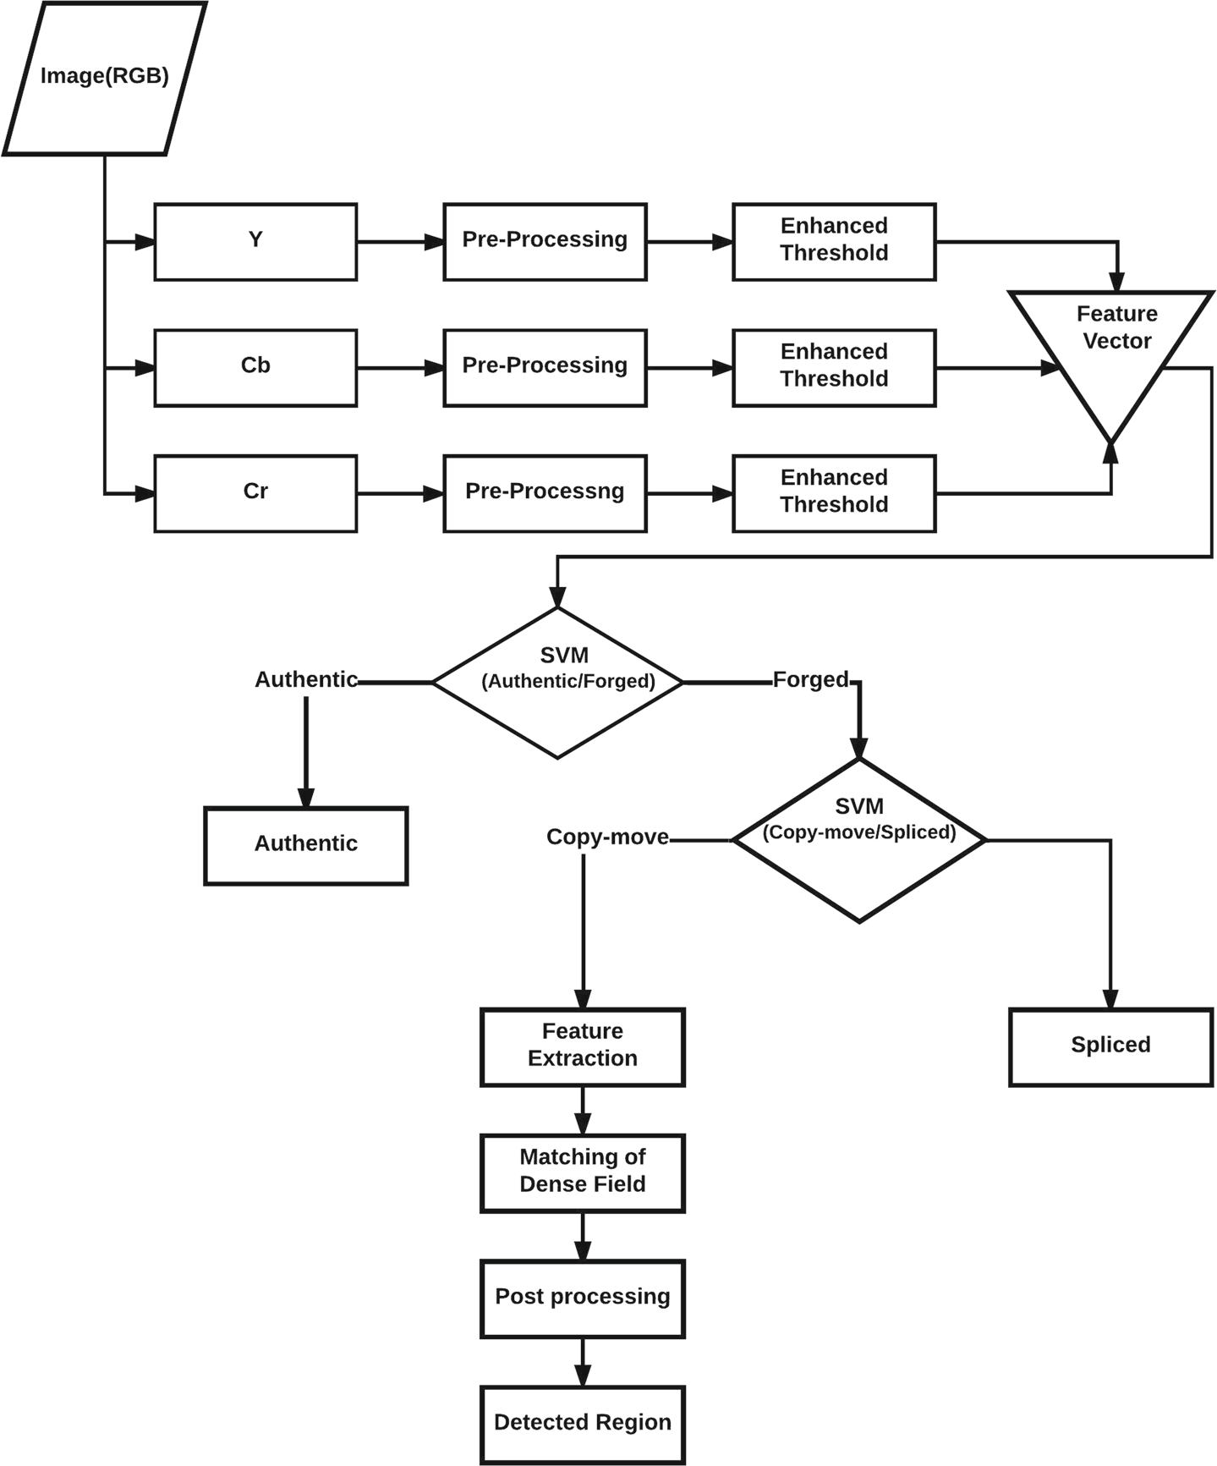

Fig. 1 Flow diagram of proposed work

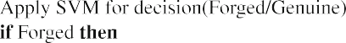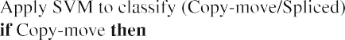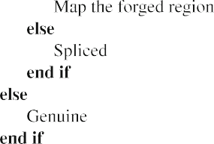
Forgery in an image, whether it is copy-moved or spiced. As discussed in the above sections, previously proposed schemes were concentrating only on the copy-move forgery detection or splicing detection separately. But in this paper, the proposed scheme can tackle both the passive forgery me, we copy-move and splicing simultaneously on the same database.

Proposed work

Inspired by the works mentioned in the Section 2, we propose a method for image forgery detection, which combines block discrete cosine transform (BDCT) and ZM-polar (Zernike moment) as shown in Fig. 1. This paper gives insight of image forgery based detection on splicing and copy-move forgery. In the proposed technique, the main contribution detects to firstly that the given image is manipulated or not. If the image manipulation is detected, then using SVM classifier, test the presence of copy-move or splicing forgery. If copy-move is detected, then further processing is done in locating the forged regions. Hence, in that respect is a two step process for the detection of forged image:
- Detection of forgery using the SVM classifier.
- Classification of forgery (Copy-move or splicing). The forgery detection algorithm is stated in Algorithm 1.

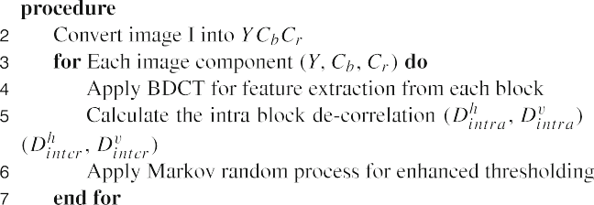

Detection of forgery using SVM classifier

In this part, we will concentrate on the process of decision making about an input image, whether it is cooked or not. In this procedure, instead of considering the luminance portion of the image for splicing artifact extraction, we will use chrominance part of the color image. Chrominance space and feature extraction procedure in chroma space is identified in point at a lower place.

Chroma space

In this report we have utilized an image format YCbCr color model (Chroma Space), which is also a family of color space same as RGB. In this color model, Y represents the alumni- nance component, whereas chrominance component or Chroma channel is represented as Cb and Cr. Chrominance components Cb and Cr can also be visualized as blue-difference and red-difference respectively. In this color model, Y component preserves most of the image contents as compare to Cb or Cr which has comparatively less image content. Fig. 2 shows an example of RGB and YCbCr color model. We have noticed that in most of the color image splicing detection method luminance component has given higher priority than chrominance component, in fact, they used only luminance part of the image for fea- tar extraction. Nevertheless, we broke down and found that the chroma channel preserves most of the splicing artifacts. Referable to the sensitivity of human eyes towards luminance over Chroma, even if manipulated images look original or authentic to human eyes, some splicing arty- facts will be left on chroma channel. Hence, to capture the splicing artifacts, chrominance part of the picture can be habituated. For further explanation, see Fig. Figure 2 is shown as an example. In Fig. 2, the region of birdmark4" 2, the region of the bird is tiEd onto the authentic image. - tour in Y, Cb and Cr components, it can be found that the image details cover up the splicing introduced edge in Y component and in Cb (or Cr) component the bird’s contour is more precipitous than the other targets present in the picture. Thus, in chroma components, the edges which are affected by splicing can be well found.
In this report, we proposed an attack based on the advanced threshold method in Chroma space to press out the features of a color image as presented in Fig. 3. In the first measure we perform non overlapping block discrete cosine transform (BDCT) and image de-correlation as a pre-processing step to cut the influence caused by the diversity of image content. In the next step enhanced threshold method is utilized in the processed image intensity matrix to draw out the discriminating feature for forgery detection. These steps are applied on all the

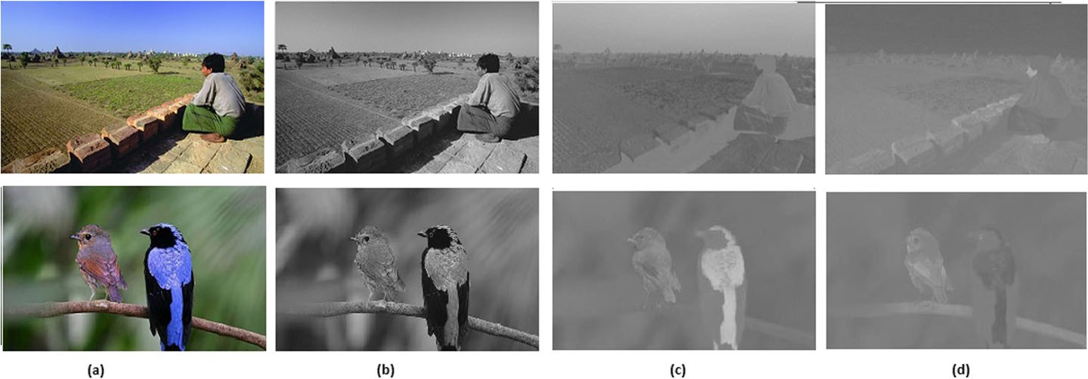
Fig. 2 Example of color model a RGB b Y-channel b Cb-channel c Cr-channel

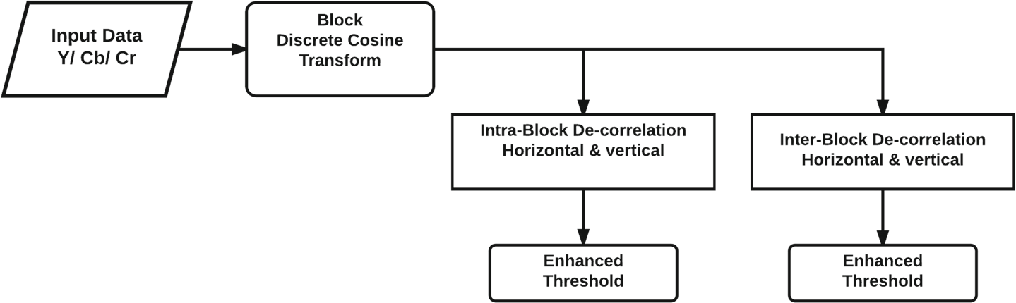

Fig. 3 Preprocessing model of proposed method.

Three channels of chrominance component Y, Cb, and Cr. Resulting features extracted from Y, Cb, and Cr component is viewed as discriminating features for categorization. We have used Support Vector Machine (SVM) with RBF kernel as classifier in which k-fold cross validation is employed to optimize the C and gamma value, results in high classification accuracy.

Image pre-processing and statistical analysis

In image forgery detection it is very hard to break up the suspicious portion of an icon from the image background.d. In parliamentary law to facilitate the separation of suspicious part of an image, we perform BDCT and image de-correlation as a pre-processing step. It takes a non- overlapping 8 8 blocks-wise transformation of the source icon. The DCT coefficient in the block is denoted by S. Fig. 3 shows the N N non overlapping BDCT. After rounding the DCT coefficient to nearest integer value, image de-correlation [64] is calculated in horizontal and vertical direction as follows:

h
D
intra
v
D
intra
= S (i, j) − S (i + 1,j) (1)
= S (i, j) − S (i, j + 1) (2)

To consider the inter-block correlation caused by 8 8 BDCT, inter-block image de- correlation is obtained in horizontal and vertical direction as follows:
×

h
D
inter
v
D
inter
= S (i, j) − S (i + 8,j) (3)
= S (i, j) − S (i, j + 8) (4)

where, i ∈ [1, Su−1], J ∈ [1, Sv −1] and S_{u} and S_{v} is the original dimension of the image.
h

S (i, j) represents the intensity value at the position (i, j), D^{h}
intra
, D
, D
v
intra
inter ,

v
D
inter
indicates de-correlated and inter-block de-correlated image in horizontal and vertical

direction respectively.

Enhanced threshold method

Since, splicing of an image affects the correlation of the original image pixels and the Markov random process is used to characterize the correlation, we proposed an enhanced threshold method based on Markov random process for feature extraction as shown in Algorithm 2. Instead of applying enhanced threshold method directly to image coefficients, this method is applied to the de-correlation matrix (1), (2), (3) and, (4) respectively.

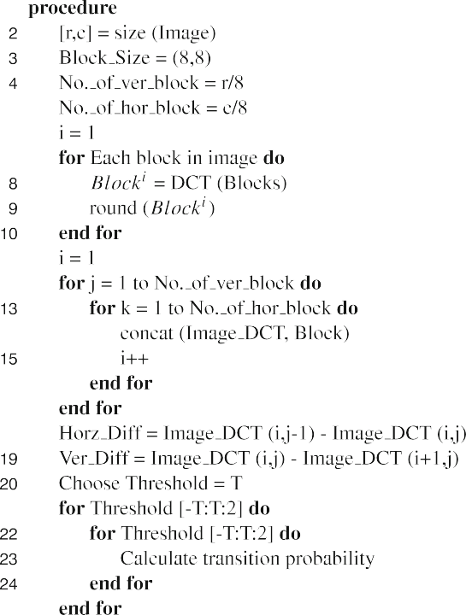

Feature extraction for copy-move forgery

In recent years, a large bit of feature extraction method has been offered. Christlein et al. [12] have considered many of them in their extensive experimental comparison. In

Where ρ0, 1 and son, m, h with suitable coefficients which ensure the orthogonality of the base function..
A finite number of (n, m) couples have been chosen to compute the finite number of features which locally represents the image. Then couple define a suitable patch size and for each pixel, FI (s) (n, m) coefficient is calculated by approximating the integral of (1) with a sum over the plot centered on us. Finally, the feature f(s) wilL be the accumulation of the magnitudes of these coefficients.
The patch size decides the local image characteristics for a respectable balance between the robust- ness and discrimination.. If the pieces are likewise low, and so it might not handle entirely the local image features and if it is too large and so they might lose resolution and leads to false alarm. Hence, to avoid unnecessary long features and decrease the time complexity of pro- cessing steps, we choose a limited feature so that it can leave the current matches. Hither, the patches of size 16 16 or 24 24 pixels are used to feature of length 12 for Zernike moment.
Today, let's see a straightforward solution for re-sample the basis function Kn, m (ρ, θ)
on the grid points (x, y) of the analysis patch,

Patch match algorithm

Patch Match [4] is a fast randomized algorithm which is employed to see the dense approximate nearest neighbor matches between image patches.s. Now to compute the patch correSpoon- dance, imagine there is a nearest neighboring field (NNF) and can be set as a function of my R2 of offset over all possible patch coordinates (locations of patch centers) in the image I, for some distance function of two patches D. Guess I is a dedicated patch cord- not in the image I and its correspondence nearest neighbor j in image J, then f (i) is simply calculated as j I. The value of f is refereed as offset which is stored in an array of size similar to the proportion of the image I.
The algorithm consists of three primary components: Initialization, propagation and random search.

Initialization The nearest neighbor is randomly initialized as
δ(s) = U(s) − s (19)
where U(s) is a bi-dimensional random variable uniform over the input image. Here, δ(s)
=
0 is ignored, as it contributes to a useless and trivial solution.. Additionally, here we are searching for matches which is almost far apart from the mark. Hence, a shape is enforced to exclude all offsets which are smaller than a given threshold, δ (s) < TD1. Initially, most of the random offsets are useless only a constituent of it some of them will be optimal or near-optimal. After initialization, to improve the NNF, an iterative procedure is done and each iteration of the algorithm examined offset in scan order (I, me from left to right or top to rear). Then each offset goes under propagation followed by random search.

Propagation In propagation phase, f (x, y) can be improved considering that the patch offsets are probably same, by using known offsetof f f (x 1, y) and f (x, y 1). For instance, say there is a good mapping at (x 1, y), we attempt to use the translation of that mapping one pixel to the right for our mathematical function at (x, y). Let D(v) be the patch distance between the patch (x, y) in I and (x, y) + v in J . Then the raw value of f (x, y) is taken every bit
−
− −
f (x, y) = arg min{D(f(x, y)), D(f(x − 1, y)), D(f(x, y − 1))} (20)
Granting to the algorithm if a good offset is available in the region are, then all of R below and right of (x, y) will be met with the right function.. It also propagate information up and left by checking offset in reverse scan order using f (x 1, y) and f (x, y 1) as our candidate offsets.

Random search The propagation step is greedy in nature and depending on the caliber of the random initialization. Hence, to belittle the danger of being snared in local minima, we improve f (x, y) by trying a sequence of candidate offset at an exponentially decreasing distance from V0:
Let V₀ = f (x, y)
u_{i} = V₀ + wα^{i}R_{i} (21)
WhererRIR_{i} is a uniform random in 1, 1 1,, , w is a large maximum search radius and α is a fixed ratio between search window size. The spots are being tested on I
0, 1, 2, ... until the current search radius wα^{i} is below 1 pixel. Here, w is the maximum image dimension and α 1/2 except where noted.
=
If the NNF is not even over the parts of involvement where a matched is looking for, then the propagation step would be ineffective and this is the hypothesis on which Patch match algorithm depends. A similar scenario is encountered in copy-move region detection.

Post-processing

After the feature matching process, obtained offset field is mostly disordered except some large smooth areas. Hence, post-processing is needed to balance the offset field to improve the probability of detection of real copy-move regions and thin out the chance of false alarm rate.
The post-processing consists of following steps:
- Apply median filtering to remove outliers on a circular window having radius ρ_{M}.
- Calculation of fitting error, ‹2 (s), w.r.t a least squares linear model over a circular region of radius ρN.
- Thresholding the fitting error ‹²(s) at level T ².
‹
- Remove the certain regions which are closer than T_{D2} pixels.
- Take away the parts which are smaller than Ts pixels.
- Mask the detected regions.
- Morphological dilation to restore the detected region with a circular structuring element of radius
ρ_{D} = ρ_{M} + ρ_{N} .

Experimental results are presented

In this segment, we have demonstrated the experimental solutions, which have been taken out in order to prove the operation of the proposed method w.r.t.t. The state of the art. The CASIA v1. 0 and CASIA v2. 0 [14] tampered image detection, evaluation dataset is used in our experi- meant to dissect the accuracy of the proposed method. The CASIA tampered image detection evaluation dataset (CTIDE) provide a more challenging and realistic image for tampering detection. CASIA v1. 0 [14] consists of 800 authentic and 921 spliced color images which is of size 384 256 and, all images are in JPEG format without any mail processing is used. Figure 4 shows some of the examples of authentic, spliced and copy-moved images from CASIA v1.0. However, CASIA v2.0 [14] has much larger set with multiple sized images and complex operation or post-processing across edges is applied. It contains 7491 authentic and 5123 tampered color images with size varies from 240 160 to 900 600 pixels. Compared to V1.0, which alone takes one image format JPEG, CASIA v2. 0 has encompassed

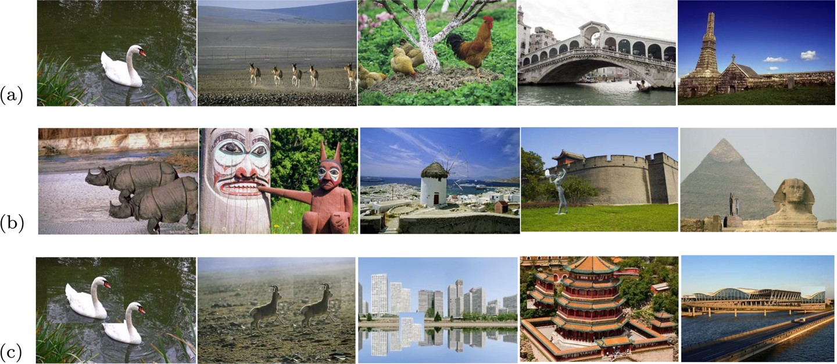

Fig. 4 Example from CASIA v1.0 databse a authentic images b spliced images c copy-move images

Image and JPEG pictures with different Q factors. The authentic images are compiled from the Corel image data set. The following ways are employed to generate the tampered images:
- Image region(s) are being cut and paste randomly.
- The copied image region(s) can be processed with different operations like resizing, rotation or other distortion and then be pasted to generate a tampered image.
- The post-processing (such as blurring) is considered after cut and paste operation to
finish the tampered image generation.
- Different sizes (small, medium and large) of tampered regions are concerned.

Detection performance of splicing forgery

In the proposed method, the experiments are employed for various threshold value. Some of the results are shown in Tables 1, 2 and 3. Threshold T=4, 6 and 8 are are chosen to evaluate the performance of proposed method for feature vector of size 600 to 1944. All the experi- ments are carried out on image dataset CASIA v1.0 and CASIA v2.0 [14]. Since, the image dataset CASIA v2.0 has more authentic images than forged images so, to keep balance between authentic and forged images, we randomly selected 5123 authentic image from available 7413 authentic images and same number of images are selected from forged cat- egory. Finally, for evaluating the performance of the proposed method we randomly select 80% of the images for training and 20% of the remaining images for testing purpose. 10 fold cross validation is performed to get the optimum γ value and finally SVM with RBF kernel is used for classification. This process is repeated 50 times to calculate the accuracy of the proposed method. Experiments with different thresholds T on same train and test database were carried out. The detection results using different image channels (Y, Cb and Cr) with different thresholds are shown in Table 1. Table 1 shows the experimental results of proposed feature in YCbCr color space on CASIA v1.0 image dataset. TPR, TNR, Accu and,MSC represents the true positive, true negative, accuracy and, misclassification rate and defined as.
Tp
TP R = Tp + Fn × 100; (22)

Table 1 Experimental result of proposed feature extraction method in Y, Cb and Cr color channel

CASIA v1.0 | T=4 |  |  |  | T=6 |  |  |  | T=8
 | Y | Cb | Cr |  | Y | Cb | Cr |  | Y | Cb | Cr
TPR | 81.87 | 85.63 | 83.125 |  | 95.625 | 93.125 | 90.625 |  | 96.25 | 95.625 | 93.75
TNR | 96.02 | 60.70 | 76.119 |  | 97.512 | 73.632 | 80.597 |  | 96.02 | 74.13 | 78.61
ACCU | 89.75 | 71.74 | 79.22 |  | 96.676 | 82.272 | 85.042 |  | 96.122 | 83.657 | 85.319
MSC | 0.103 | 0.28 | 0.208 |  | 0.0332 | 0.178 | 0.149 |  | 0.039 | 0.163 | 0.149

where,

Tp
TNR = Fp + Tn × 100; (23)
MSC Fp + Fn (24)
= ;
Tp + Fn + Fp + Tn
Accu Tp + T n (25)
= ;
Tp + Fn + Fp + Tn

Tp=Number of authentic images correctly detected. Tn=Number of spliced images correctly detected. Fp=Number of authentic images falsely detected. Fn=Number of spliced images falsely detected.
From Table 1, it is observed that detection accuracy of proposed method is 96.12%, 83.66% and, 85.32% for Y, Cb and Cr feature set respectively, if we set t=8, whereas for T=6 and T=4 detection accuracy get decreased by 1% to 3%. Table 1 shows that threshold value 4 has higher misclassification (MSC) of 0.103, 0.28 and, 0.208 for different feature set (Y, Cb and Cr). But if we combine all the feature set (Y+Cb+Cr) as shown in Table 2, for T=4 MSC rate reduced to 0.02, likewise for other threshold values too. As shown in Table 2 threshold T=8 shows the highest accuracy of 99.45 with MSC rate of 0.0055, which is much lower than MSC rate of individual feature set. However, the dimension of feature vector increases up to 1944 which is much higher, as compare to dimension 600 for T=4. From Tables 1 and 2 it is concluded that the combined feature set (Y+Cb+Cr) exhibit much higher accuracy rate than considering feature set individually. All these experiments are carried out on CASIA v1.0 splicing evaluation dataset.
In order to verify the accuracy of proposed method, we performed the experiment on CASIA v2.0 image evaluation dataset, which is much larger and complex dataset than CASIA v1.0. Experimental results of CASIA v2.0 dataset are shown in Table 3. We

Table 2 Experimental result of proposed method for threshold T=4, T=6 and T=8

CASIA v1.0 Y+Cb+Cr | T=4 Y+Cb+Cr | T=6 Y+Cb+Cr | T=8
TPR | 96.875 | 98.750 | 99.375
TNR | 98.5075 | 96.5175 | 99.5025
ACCU | 97.78 | 97.51 | 99.45
MSC | 0.022 | 0.024 | 0.0055

Table 3 Detection result of proposed method for different threshold value on CASIA v2.0

CASIA v2.0 | T=4 | T=6 | T=8
 | Y+Cb+Cr | Y+Cb+Cr | Y+Cb+Cr
TPR | 95.775 | 97.720 | 98.525
TNR | 97.525 | 96.212 | 98.71
ACCU | 96.68 | 96.966 | 98.89
MSC | 0.027 | 0.025 | 0.0075

performed this experiment on threshold T=4, T=6 and T=8, and combined feature set (Y+Cb+Cr) is used as discriminative feature for classification. From Table 3 it can be observed that for T=8 proposed method performs well with accuracy 98.89% and MSC rate of 0.0075, whereas for T=4 and T=6, we are getting an accuracy of 96.68% and 96.96% respectively. It depicts that for the cost of high dimensional feature vector we are getting better accuracy. We believe that future work can be carried out on dimension reduction of feature vector without loosing important features.
Finally, to evaluate the efficiency of the proposed technique, we have compared the pro- posed technique with some existing state-of-the-arts for image splicing detection, which includes Q. Zhang et.al. [60], SRM [27, 43], He et al. [21], and SPAM [41]. Q. Zhang
[60] proposed a method in which features are extracted through Markov approach in DCT domain and Contourlet transform domain by characterizing the dependency of positions among Contourlet sub-band. For gray image, these features are extracted from single color channel and for color image three color channels are used. In Qiu et al. [43] method it is stated that the change occur in correlations between image pixels due to splicing, are par- tially similar to steganography. Due to which some of the universal steganalysis features are used for splicing detection which is introduced in [27] denoted by SRM and achieved an effective detection capability. Here, SRM is used for comparison in our experiments.
The detailed results of comparisons of each method are given in Table 4. It can be seen from Table 4 that our proposed method outperform some state of the art method with an accuracy of 99.44%. However, dimension of the feature vector is higher than SPAM [41]. From Table 4, it can be observed that our proposed method has more stable result with highest true positive rate, true negative rate and accuracy.

Detection performance of copy-move forgery

In the proposed copy-move forgery detection algorithm, there are number of numeri- cal parameters to be defined. After performing some initial experiments, the values of

Table 4 Comparison with existing method on CASIA v1.0 database

Techniques | Dimension | TPR | TNR | ACCU
Q. Zhang et al. [60] | 16524 | 98.06 | 95.31 | 96.69
SRM [27, 43] | 34671 | 97.65 | 96.74 | 97.19
He et al. [21] | 100(7290) | 96.37 | 96.74 | 97.19
SPAM [41] | 686 | 90.90 | 89.55 | 90.16
Proposed | 1944 | 99.37 | 99.50 | 99.44

Table 5 Values of relevant parameters used in the proposed technique
Parameters | Value | Meaning
TD1 | 8 | Minimum length of offset
ρ_{M} | 4 | Radius of median filter
ρ_{N} | 6 | Radius of dense linear fitting
T 2 | 300 | Threshold on dense linear fitting
TD2 | 50 | Minimum distance between clones
T_{S} | 1200 | Minimum size of clones
ρ_{D} | 10 | Radius of morphological dilation

‹

parameters are set which are shown in Table 5. For detection of copy-move forgery, an appropriate measure is required to evaluate the performance of the proposed method. Here, TPR and TNR are used as performance measures which are defined in Section 4.1. In this section, we have applied simple copy-move on CASIA v1.0 database to create some forged image for experiments. We have trained our system with authentic and forged image to detect the manipulated image with the duplicated area efficiently. For this purpose, we have used SVM classifier which classify the forged and authentic images. Further, copy-move technique detect the duplicated regions. Initially an image is taken as the input to the pro- posed method. The proposed method detect whether the image is spliced or copy-moved. In this case we have input a copy-move forged image. As result, the proposed method detect the manipulated region successfully and some of the examples which are forged with irreg- ular regions and the proposed method detect the duplicated regions successfully are shown in Fig. 5.
To evaluate the effect of duplicated region size (48 48, 64 64 and 128 128) on CASIA v1.0 were tested. The images were manipulated by copying a square region at a random position and pasting it onto a non-overlapping region. The detection results are quite satis- factory and can be seen from the Fig. 6. In Table 6, it is observed that the TPR is increasing with the size of the copied region. Proposed method can easily detect the manipulated region efficiently with the TPR of 87.50%, 91.33% and 93% for 48 48, 64 64 and 128 128 square region respectively. To justify the robustness of the proposed method against post- processing, we have also applied it on the images after copy-move manipulation. Here, noise, smoothening, rotation and scaling are taken as the post-processing operations. As it is shown in Table 7, proposed method can detect the manipulation efficiently in the pres- ence of all the above mentioned post-processing. When the noise is applied on the images, the observed TPR is 93.33%. Similarly, when the smoothening, rotation and scaling applied then 86.66%, 88% and 84% TPR is observed respectively on each post-processing opera- tion. These results depicts the robustness of the proposed method against the post-processing operations.
× × ×
× × ×
For comparison of the proposed method with the existing techniques [6, 22, 24], an open source CASIA v1.0 dataset [14] is selected to evaluate the performance. CASIA v1.0 can be grouped into two categories: authentic image dataset (AU) and spliced image dataset (SP), which may be copy-move tampered in the same image or the other image without

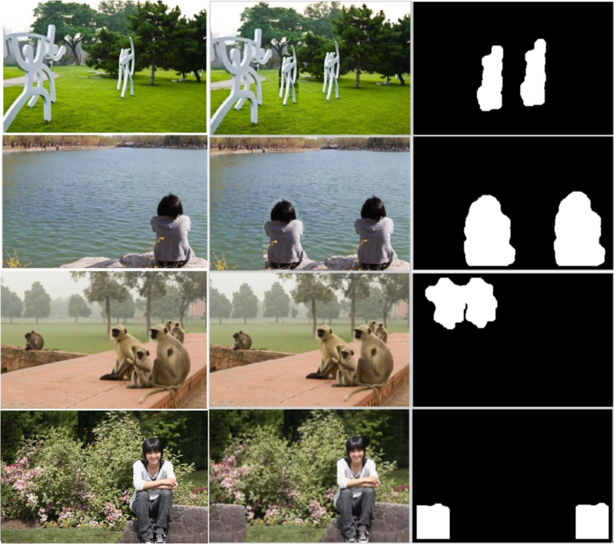

Fig. 5 Detection results for copy-move forgery. From left to right: Original image, duplicated image and detected region of the proposed method

performing any post-processing operations. CASIA v1.0 dataset contains 800 authentic and 921 copy-moved images of size 384 286 pixels in JPEG format. Authentic images are considered for the performance comparison of the existing techniques [6, 22, 24] because the ground truth of the copy-moved images are not available. It cn be observed from the Table 8, that the proposed method have accuracy of 87.5% where as the existing methods of Bianchi & Piva [6], Hu et al. [22] and Huang et al. [24] have 65.75%, 80.38% and 86.63% respectively on CASIA database. The comparison results can be seen from the Table 8 and it is observed that the proposed method perform well in simple copy-move forgery.
×

Conclusion

In this paper, image forgery detection method is proposed which can deal with the splicing as well as copy-move forgery at the same time. Initially, an image is taken and converted into Y C_{b}C_{r} channels. The chrominance channels are considered to extract the features as it preserves most of the splicing artifacts. Then BDCT and image de-correlation is performed as pre-processing steps. After combining all the extracted features, we train the system with genuine and forged images. SVM is used to classify whether an image is spliced or copy-moved. Then to detect the forged region copy-move detection technique is applied to map the duplicated region. The experimental results shows the efficiency of the proposed method. In case of splicing detection, it is observed that the accuracy rate at threshold T=8, is 99.50%. In case of copy-move the accuracy is 87.50% which shows the robustness of the proposed method. We have also compared the proposed method with the existing techniques as shown in Tables 4 and 8 which depict the efficiency of the proposed method is quite satisfactory. However, in future work, we will try to implement it on more complex database to test the effectiveness of the proposed work.

References

- Amerini I, Ballan L, Caldelli R, Bimbo AD, Serra G (2011) A sift-based forensic method for copy–move attack detection and transformation recovery. IEEE Trans Inf Forensics Secur 6(3):1099–1110
- Amerini I, Ballan L, Caldelli R, Bimbo AD, Tongo LD, Serra G (2013) Copy-move forgery detection and localization by means of robust clustering with j-linkage. Signal Process Image Commun 28(6):659–669
- Andreopoulos A, Tsotsos JK (2013) 50 years of object recognition directions forward. Comput Vis Image Underst 117(8):827–891
- Barnes C, Shechtman E, Finkelstein A, Goldman DB (2009) Patchmatch: A randomized correspondence algorithm for structural image editing. ACM Trans Graph 28(3):24–1

- Bayram S, Sencar HT, Memon N (2009) An efficient and robust method for detecting copy-move forgery. In: Acoustics, Speech and Signal Processing, 2009. ICASSP 2009. IEEE International Confer- ence on, pp 1053–1056. IEEE
- Bianchi T, Piva A (2012) Image forgery localization via block-grained analysis of jpeg artifacts. IEEE Trans Inf Forensics Secur 7(3):1003–1017
- Bo S, Yuan Q, Wang S, Zhao C, Li S (2014) Enhanced state selection markov model for image splicing detection. EURASIP J Wirel Commun Netw 2014(1):7
- Bravo-Solorio S, Nandi AK (2011) Automated detection and localisation of duplicated regions affected by reflection, rotation and scaling in image forensics. Signal Process 91(8):1759–1770
- Campos FM, Correia L, Calado JMF (2015) Robot visual localization through local feature fusion: an evaluation of multiple classifiers combination approaches. J Intell Rob Syst 77(2):377–390
- Cao Y, Gao T, Li F, Yang Q (2012) A robust detection algorithm for copy-move forgery in digital images. Forensic Sci Int 214(1):33–43
- Chen L, Wei L, Ni J, Sun W, Huang J (2013) Region duplication detection based on harris corner points and step sector statistics. J Vis Commun Image Represent 24(3):244–254
- Christlein V, Riess C, Jordan J, Riess C, Angelopoulou E (2012) An evaluation of popular copy-move forgery detection approaches. IEEE Trans Inf Forensics Secur 7(6):1841–1854
- Dollar P, Wojek C, Schiele B, Perona P (2012) Pedestrian detection: An evaluation of the state of the art. IEEE Trans Pattern Anal Mach Intell 34(4):743–761
- Dong J, Wang W, Tan T (2013) Casia image tampering detection evaluation database. In: Signal and information processing (ChinaSIP), 2013 IEEE China Summit & International Conference on, pp 422–
426. IEEE
- El-Alfy E-SM, Qureshi MA (2015) Combining spatial and dct based markov features for enhanced blind detection of image splicing. Pattern Anal Applic 18(3):713–723
- Fischler MA, Bolles RC (1981) Random sample consensus: a paradigm for model fitting with applications to image analysis and automated cartography. Commun ACM 24(6):381–395
- Fridrich AJ, Soukal BD, Luka´sˇ AJ (2003) Detection of copy-move forgery in digital images. In Inproceedings of Digital Forensic Research Workshop. Citeseer
- Gionis A, Indyk P, Motwani R et al (1999) Similarity search in high dimensions via hashing. In: VLDB, vol. 99, pp 518–529
- Guo J-M, Liu Y-F, Wu Z-J (2013) Duplication forgery detection using improved daisy descriptor. Expert Syst Appl 40(2):707–714
- Hakimi F (2015) Image-splicing forgery detection based on improved lbp and k-nearest neighbors algorithm. Electron Inf Plan, 3
- He Z, Wei L, Sun W, Huang J (2012) Digital image splicing detection based on markov features in dct and dwt domain. Pattern Recogn 45(12):4292–4299
- Hu W-C, Dai J-S, Jian J-S (2015) Effective composite image detection method based on feature inconsistency of image components. Digital Signal Process 39:50–62
- Huang Y, Wei L, Sun W, Long D (2011) Improved dct-based detection of copy-move forgery in images. Forensic Sci Int 206(1):178–184
- Huang D-Y, Huang C-N, Hu W-C, Chou C-H (2017) Robustness of copy-move forgery detection under high jpeg compression artifacts. Multimedia Tools and Applications 76(1):1509–1530
- Jain AK, Ross AA, Nandakumar K (2011) Introduction. In: Introduction to Biometrics, pp 1–49. Springer
- Kakar P, Sudha N (2012) Exposing postprocessed copy–paste forgeries through transform-invariant features. IEEE Trans Inf Forensics Secur 7(3):1018–1028
- Kodovsky J, Fridrich J, Holub V (2012) Ensemble classifiers for steganalysis of digital media. IEEE Trans Inf Forensics Secur 7(2):432–444
- Langille A, Gong M (2006) An efficient match-based duplication detection algorithm. In: Computer Robot Vision The 3rd Canadian Conference on, pp 64–64. IEEE
- Lazebnik S, Schmid C, Ponce J (2005) A sparse texture representation using local affine regions. IEEE Trans Pattern Anal Mach Intell 27(8):1265–1278
- Li Y (2013) Image copy-move forgery detection based on polar cosine transform and approximate nearest neighbor searching. Forensic Sci Int 224(1):59–67
- Li X, Jing T, Li X (2010) Image splicing detection based on moment features and hilbert-huang trans- form. In: 2010 IEEE international conference on information theory and information security (ICITIS), pp 1127–1130. IEEE
- Li L, Li S, Zhu H, Wu X (2014) Detecting copy-move forgery under affine transforms for image forensics. Comput Electr Eng 40(6):1951–1962
- Li L, Li C, Ye L, Jia Y, Rosenblum DS (2016) Recognizing complex activities by a probabilistic interval- based model. In: AAAI, vol. 30, pp 1266–1272

- Liu S, Bai X (2012) Discriminative features for image classification and retrieval. Pattern Recogn Lett 33(6):744–751
- Lu Y, Ye W, Li L, Zhong J, Sun L, Ye L (2017) Towards unsupervised physical activity recognition using smartphone accelerometers. Multimedia Tools and Applications 76(8):10701–10719
- Mahdian B, Saic S (2007) Detection of copy–move forgery using a method based on blur moment invariants. Forensic Sci Int 171(2):180–189
- Moreels P, Perona P (2007) Evaluation of features detectors and descriptors based on 3d objects. Int J Comput Vis 73(3):263–284
- Muhammad G, Hussain M, Bebis G (2012) Passive copy move image forgery detection using undeci- mated dyadic wavelet transform. Digit Investig 9(1):49–57
- Muja M, Lowe DG (2009) Fast approximate nearest neighbors with automatic algorithm configuration. VISAPP (1) 2(331-340):2
- Pan X, Lyu S (2010) Region duplication detection using image feature matching. IEEE Trans Inf Forensics Secur 5(4):857–867
- Pevny T, Bas P, Fridrich J (2010) Steganalysis by subtractive pixel adjacency matrix. IEEE Trans Inf Forensics Secur 5(2):215–224
- Pun C-M, Bo L, Yuan X-C (2016) Multi-scale noise estimation for image splicing forgery detection. J Vis Commun Image Represent 38:195–206
- Qiu X, Li H, Luo W, Huang J (2014) A universal image forensic strategy based on steganalytic model. In: Proceedings of the 2nd ACM workshop on Information hiding and multimedia security, pages 165–170. ACM
- Rahmani R, Goldman SA, Zhang H, Krettek J, Fritts JE (2005) Localized content based image retrieval. In: Proceedings of the 7th ACM SIGMM international workshop on Multimedia information retrieval, pp 227–236. ACM
- Ryu S-J, Lee M-J, Lee H-K (2010) Detection of copy-rotate-move forgery using zernike moments. In: Information hiding, vol. 6387, pp 51–65. Springer
- Ryu S-J, Kirchner M, Lee M-J, Lee H-K (2013) Rotation invariant localization of duplicated image regions based on zernike moments. IEEE Trans Inf Forensics Secur 8(8):1355–1370
- Shi Y, Chen C, Chen W (2007) A natural image model approach to splicing detection. In: Proceedings of the 9th workshop on Multimedia & security, pp 51–62. ACM
- Shivakumar BL, Baboo S (2011) Detection of region duplication forgery in digital images using surf. Int J Comput Sci Issues 8(4):199–205
- Sutthiwan P, Shi Y, Su W, Ng T-T (2010) Rake transform and Edge statistics for image forgery detec- tion. In: Multimedia and Expo (ICME), 2010 17th IEEE International Conference on, pp 1463–1468. IEEE
- Sutthiwan P, Shi Y-Q, Dong J, Tan T, Ng T-T (2010) New developments in color image tampering detection. In: Circuits and Systems (ISCAS), Proceedings of 2010 IEEE International Symposium on, pp 3064–3067. IEEE
- Sutthiwan P, Shi Y, Zhao H, Ng T-T, Su W (2011) Markovian rake transform for digital image tampering detection. Transactions on data hiding and multimedia security VI 6:1–17
- Wang W, Dong J, Tan T (2009) Effective image splicing detection based on image chroma. Image Processing (ICIP), 2009 16th IEEE International Conference on, pp 1257–1260. IEEE
- Wang W, Dong J, Tan T (2010) Image tampering detection based on stationary distribution of markov chain. In: Image Processing (ICIP), 2010 17th IEEE International Conference on, pp 2101–2104. IEEE
- Wu X, Fang Z (2011) Image splicing detection using illuminant color inconsistency. In: 2011 3rd inter- national conference on multimedia information networking and security (MINES), pp 600–603. IEEE
- Xin Y, Pawlak M, Liao S (2007) Accurate computation of zernike moments in polar coordinates. IEEE Trans Image Process 16(2):581–587
- Yap P-T, Jiang X, Kot AC (2010) Two-dimensional polar harmonic transforms for invariant image representation. IEEE Trans Pattern Anal Mach Intell 32(7):1259–1270
- Ye L, Nie L, Han L, Zhang L, Rosenblum DS (2015) Action2activity: Recognizing complex activities from sensor data, In: IJCAI, pp 1617–1623
- Ye L, Nie L, Li L, Rosenblum DS (2016) From action to activity: Sensor-based activity recognition. Neurocomputing 181:108–115
- Ye L, Zhang L, Nie L, Yan Y, Rosenblum DS (2016) Fortune teller: Predicting your career path, In: AAAI, pp 201–207
- Zhang Q, Wei L, Weng J (2016) Joint image splicing detection in dct and contourlet transform domain. J Vis Commun Image Represent 40:449–458

- Zhao J, Zhao W (2013) Passive forensics for region duplication image forgery based on harris feature points and local binary patterns. Math Probl Eng 2013:12
- Zhao X, Li J, Li S, Wang S (2011) Detecting digital image splicing in chroma spaces. Digital Watermarking 6526:12–22
- Zhao X, Wang S, Li S, Li J (2015) Passive image-splicing detection by a 2-d noncausal markov model. IEEE Trans Circuits Syst Video Technol 25(2):185–199
- Zou D, Shi YQ, Su W, Xuan G (2006) Steganalysis based on markov model of thresholded prediction- error image. In: Multimedia and Expo, 2006 IEEE International Conference on, pp 1365–1368. IEEE


Choudhary Shyam Prakash is currently a Ph.D. scholar in the Department of Computer Science and Engineering at Indian Institute of Technology (Indian School of Mines), Dhanbad, India. He received his B.Tech from Aryabhatta Knowledge University Patna, India in 2012. His research interests includes Image processing, Image Forensics.


Avinash Kumar has completed his M. Tech. CSE with the specialisation in Information Security from IIT(ISM) Dhanbad, India in 2017. He received his B. Tech from St. Peters University Chennai, India in 2012. His research interests includes Image forensics, Image processing.


Dr. Sushila Maheshkar is an Assistant Professor at CSE Department in IIT(ISM) Dhanbad. She earned her
B.E. in Computer Technology from Nagpur University, M. Tech in Computer Science & Engineering from RGPV Bhopal and Ph.D from Motilal Nehru National Institute of Technology, Allahabad. She is a member of IEEE and ACM organizations and served as a reviewer for various IEEE/ACM/Springer/Elsevier journals and conferences. She is having more than 10 years of teaching experience. Her current research interest includes Digital Image watermarking, Pattern Recognition, Computer Vision, Computer Forensics, Compression and Biometrics. She has authored or coauthored more than 15 publications in international jounals and more than 35 publications in international conferences of repute.


Dr. Vikas Maheshkar is an Assistant Professor at Faculty of Information Technology in NSIT Delhi. He earned his B.E. in Computer Technology from Nagpur University, M. Tech in Computer Science & Engi- neering from RGPV Bhopal and Ph.D from Motilal Nehru National Institute of Technology, Allahabad. His current research interest includes Digital Image watermarking, Pattern Recognition, Computer Vision, Computer Forensics, Compression and Biometrics.

